**Quick Reference Guide**

**How to Manage a Public Holiday Unavailability – DL (2024)07 Annual Leave Policy**

APF have agreed that the Annual Leave DL which was published last year must be implemented with immediate effect and will apply retrospectively back to April 2024.

Guidance is provided for 3 scenarios:

* Adding retrospective leave for public holidays for 2024/25 if daily hours are greater than those defined in DL (2024) 07 for public holidays.
* Recording PH Unavailability and Annual Leave Entitlement for 2025/26 in Optima when daily hours are greater than those defined in DL (2024) 07 for public holidays.
* Recording PH Unavailability and Annual Leave Entitlement for 2025/26 in Optima when daily hours are less than those defined in DL (2024) 07 for public holidays.

**Scenario 1: Adding retrospective leave for public holidays for 2024/25 if daily hours are greater than those defined in DL (2024) 07 for public holidays.**

Click on **Change Entitlement**. Enter retrospective hours due to section – Agreed Carry Forward Hours and select **OK** to confirm.



The balance will now be updated to add on any carry forward hours due.

**Scenario 2 : Recording PH Unavailability and Annual Leave Entitlement for 2025/26 in Optima when daily hours are greater than those defined in DL (2024) 07 for public holidays e.g.** **employee works full-time on compressed hours - 11.5 hr shift on PH Day**

If they take a public holiday off they deduct 7.5 hours from their public holiday entitlement. They do not take any hours from the annual leave entitlement to make up the 11.5 hour shift they would have worked.

1. Navigate to Rostering → View Rosters

Public Holiday should be recorded as:

* 7.5 hours public holiday (taken from leave entitlement as -7.5 hrs)
* 4 additional hours recorded as “leave” but **not** deducted from entitlement

2. From the roster select the PH unavailability you need to edit, and in the panel that appears select the **Edit Unavailability** action

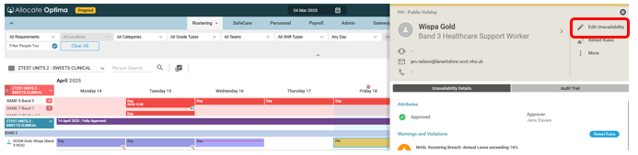

3. Edit the hours being deducted from 11:30 to 07:30 and select **OK** to confirm.

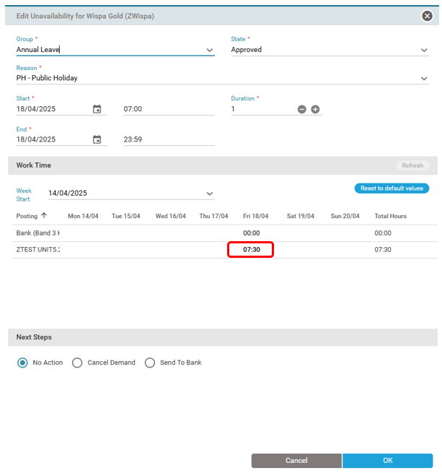

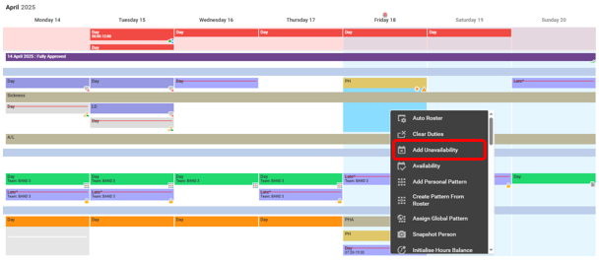4. From the roster again, select the person and the day that the Public Holiday is falling on and **Add Unavailability**

5. In the panel that appears, populate the **Unavailability Group** with Other Leave, the **Unavailability Reason** as Other Leave – PHA (Public Holiday Adjustment),the **Status** as Approvedand the **work time** as 4 hours (e.g. 11.5 - 7.5 = 4 hours PHA hrs - this will **not** deduct from entitlement allowance). Once you have made the changes, select **OK** to confirm.

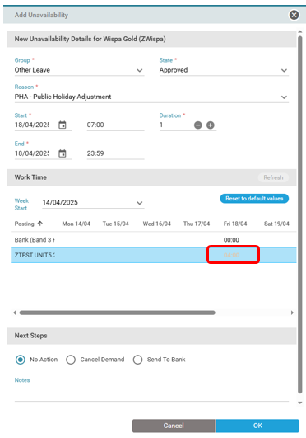

This will record the Unavailability as 11.5 hrs to balance contracted hours without impacting the entitlement (7.5 hours only deducted as unavailability from AL entitlement)

6. Navigate to Rostering → View Rosters



7. Click on the person’s name and in the panel that appears, click on the persons name, then navigate to **Entitlements.**

8. Under **Entitlement Period**, select **Annual Leave** and populate the current leave year **From** and **To** date. Click on Search.

9. Click on entitlement period to be amended.



**Scenario 3 : Recording PH Unavailability and Annual Leave Entitlement for 2025/26 in Optima when daily hours are less than those defined in DL (2024) 07 for public holidays.**

Part-time employee 33 hours a week. They work 3 hours on a Monday, and 7.5 hours Tuesday to Friday. Public Holiday entitlement is 53 hours per year; 7 hours per public holiday.

If they take a public holiday off on a Monday they deduct 7 hours from their public holiday entitlement.

1. From the View Roster screen, select the person and the day that the Public Holiday is falling on and **Add Unavailability** as normal for hours due to be worked that day (e.g. 3 hrs).

2. Once availability has been added, from View Roster Screen again, click on their name.

3. Navigate to Entitlements Section. Select Entitlement Period as Annual Leave and enter From and To date for current leave year, then click on search button.

4. Click on Person Entitlement as highlighted above.

5. Click on Change Entitlement

6. In Lieu Hours section enter -4.00 hrs, Click OK. Please note, for subsequent public holidays you will need to sum hours i.e. if adding a further -4.00hrs you will need to enter the total of -8.00hrs.

7. Navigate to Notes section and click on Add Note and enter reason for adjustment i.e. as per **DL (2024)07 Annual Leave Policy**.

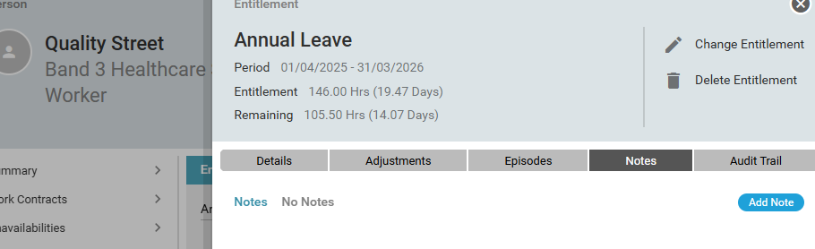

These hours will be deducted from Entitlement as per DL for this period only and will not impact the nett hours on the View Roster Screen.